Weatherman User Manual

Daniel Andrus, Johnathan Ackerman, Mackenzie Smith

**Introduction:** This document covers the running of the program, as well as usage of the various features of the program. It will also mention some known bugs and how to avoid them.

**Building/Compilation:** To run this program, open NetBeans and then open the project GUI-PA-1

**Usage:**

1. **Opening XML files**

To open data files in this program, simply click on File and then Open. Find a directory with the xml data files and then you have options:

* 1. **Open directory:** When you have selected a directory with xml files, you can click open and the program will open all contained xml files.

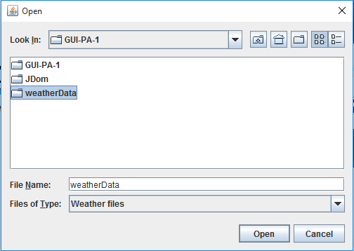

* 1. **Open files:** To open specific xml files, navigate to the data folder, then ctrl-click on the desired files and then click open

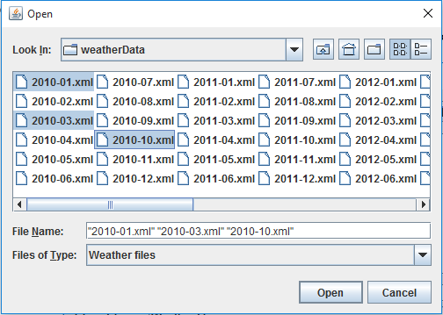

1. **Manipulating the line graph:**  After data is loaded from the xml files, the graph will be blank until you mouse over it. Then it will display the data from the first date to the last all in one big red line. There are a number of radio buttons on the main GUI frame that can change either the data displayed, or the domain.
   1. **Navigating the graph:** The line graph is interactive, meaning you can click and drag through the graph. You can also zoom in and out using a scroll wheel.
   2. **Date Tabs:** There are four different date radio buttons that will change the range of dates of the viewable data. They all calculate their end date based on the date in the “Start Date” spinner which is the spinner on the left. The graph will then be updated to be either a day, week, month, or year from the start date. **NOTE:** Although these are radio buttons, when you select a time interval and then manipulate the start or end dates, you will need to reselect the time interval to update the graph again.
   3. **Data Buttons:** These buttons are the various on the lower right portion of the UI. They update the line graph to display the corresponding data point. **NOTE**: These are radio buttons, so only one data option can be selected at any one time.
2. **Other Features:** These include the labels which display average data fields, and the tooltips for hovering over a data point on the line graph.
   1. **Tooltips:** After loading data into the graph, you can mouse through the graph as mentioned in the previous section. The graph calculates the “nearest” data point to the mouse cursor, it then draws a red vertical line to indicate the highlighted point. If you click, then the data for that point will be displayed in the labels below the graph. You can also hover the mouse over the point and a tooltip with the same data will appear for a short time.

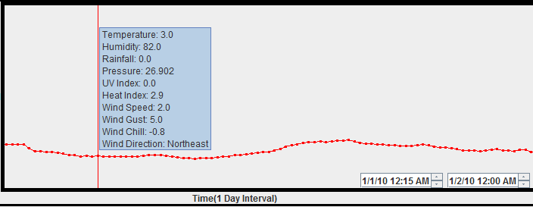

* 1. **Labels:** These are simple JLabels that display the average data for the given time interval as well as the data for the selected data point.

1. **Known Bugs:**
   1. **Start date > end date:** This bug occurs when the start date spinner has a date later than the end date spinner. When incrementing the end date spinner to go past the start date, the program will lock up as soon as you try to make the two spinners equal. **SOLUTION:** To avoid this, simply don’t increment the date by minutes unless the start date is clearly before the end date.

